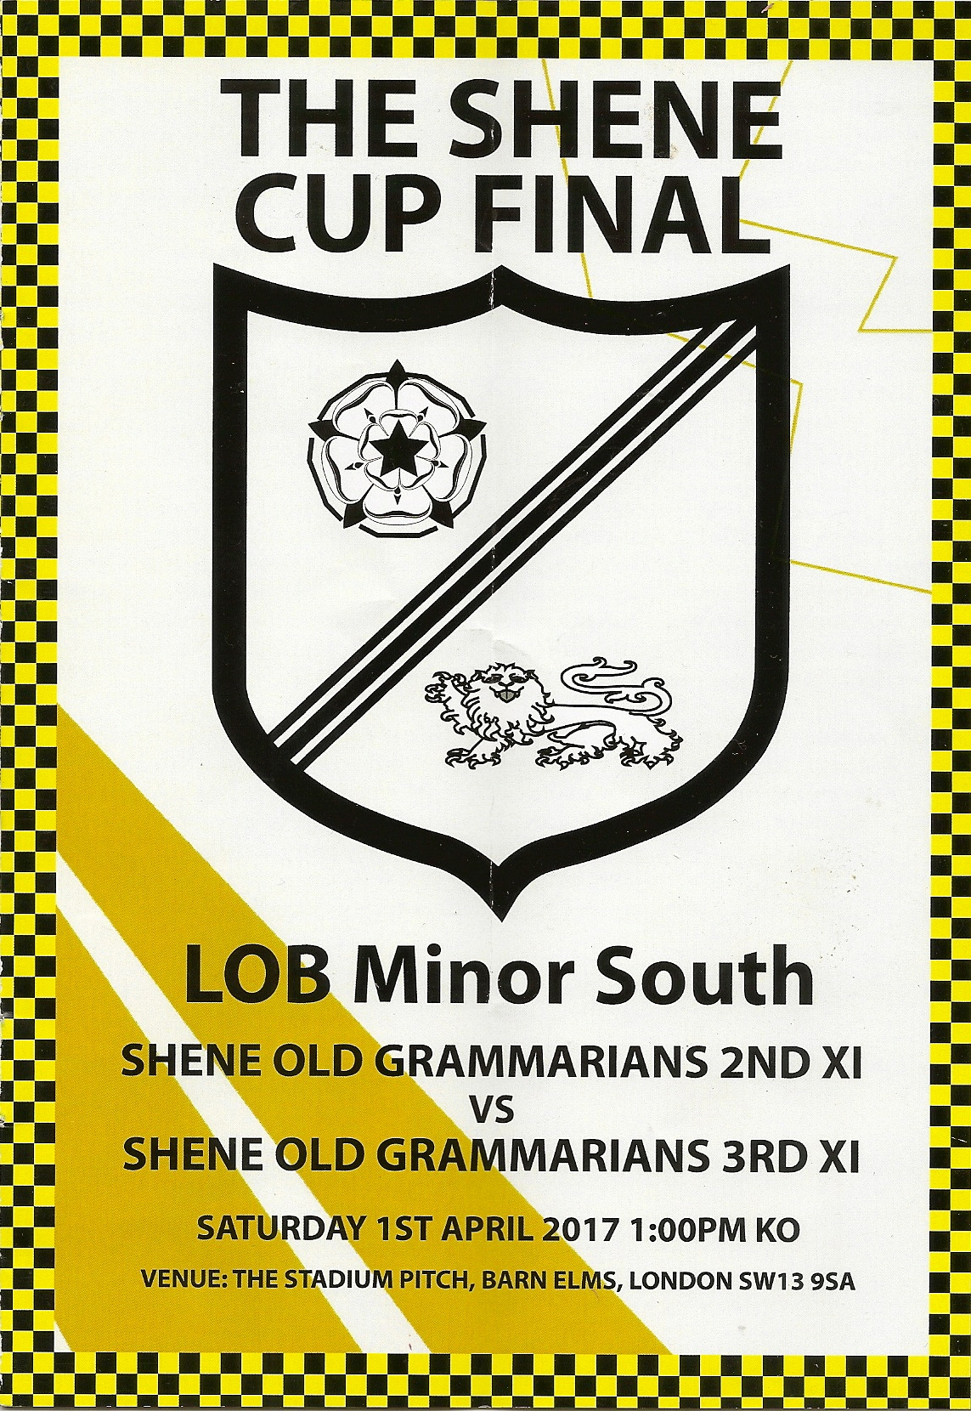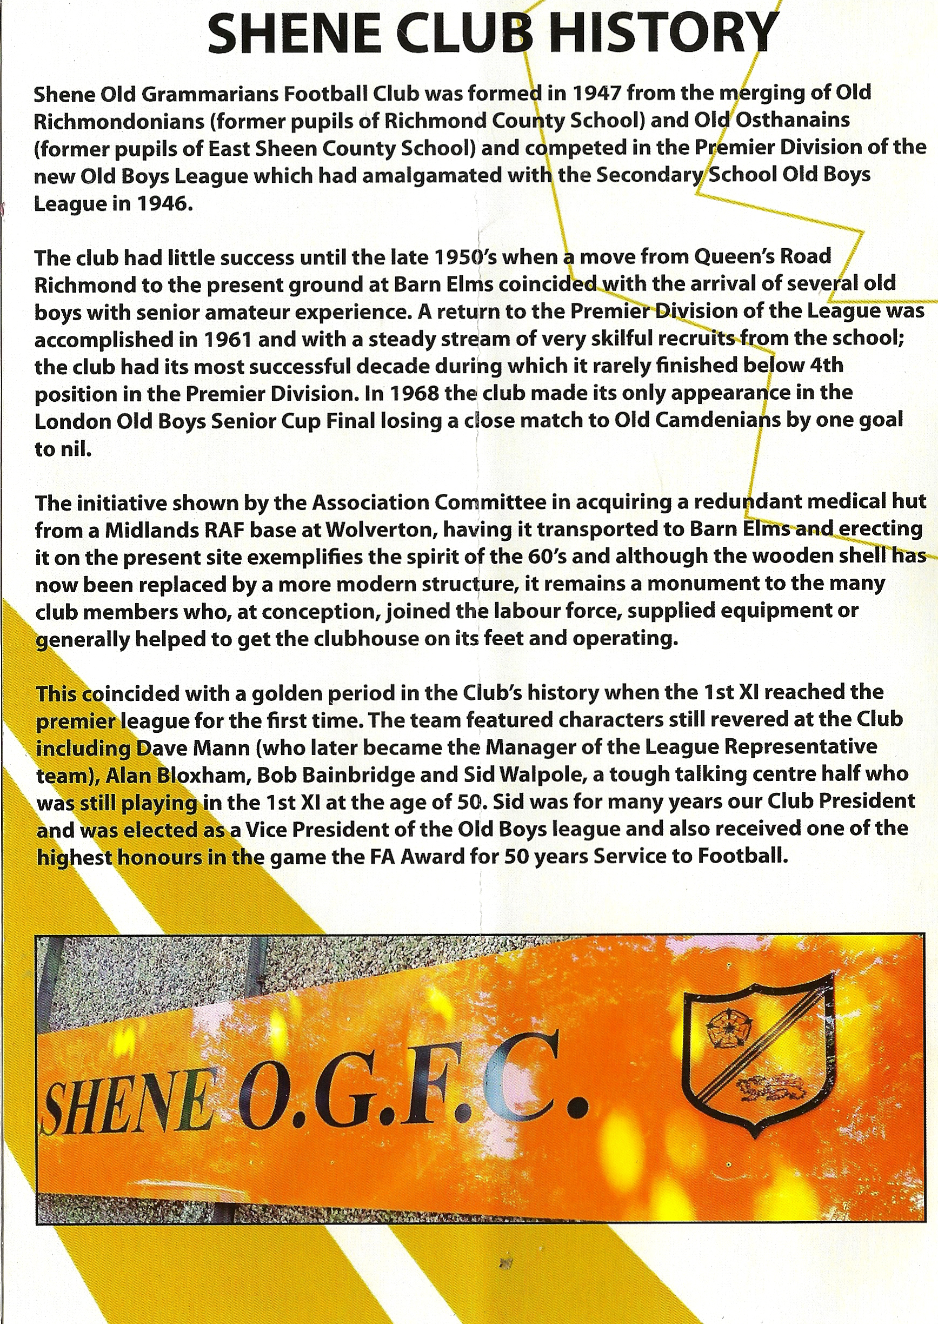

A gathering in and around the stand that overlooks the stadium ground at Barn Elms included several original Shene Old Grammarians who remembered the old set-up before the clubhouse near the adjacent Wetlands was constructed from a building rescued from an RAF base and constructed by the OGs themselves. .The programme for £2 including a meal, detailed the history of those days when the Grammar School provided new members before the School closed in the late 1970s. The supply of recruits was thereby reduced and the OGs became an ‘open’ Club. The spirit lives on but in a more modern passing style of footballing and demonstrated the same enthusiasm but higher fitness and skill levels which at no time overspillled into the more needless aspects of the modern professional game.

The score of 5-1 to the Second XI was perhaps to be anticipated and the London Cup was duly presented by League officials. This was a good contest, keenly fought in the right spirit, and the spectators were rewarded by reasonable weather conditions for a 1pm kick-off.

OGs who attended: David Phillips (who alerted David Richardson to the event), Mark Rayner, Mike Turner, John Bean and Mrs Bean, Morgan Reynolds, Peter Jeffs, David Richardson, Colin Head, Nick Crisp, Terry Gazzard, David Mann (who was presented to the teams as an OG legend), Ron Piper (who took the photographs), Robert (Ted) Bates, Robin Walpole, Richard Hackwell and a keen onlooker from Holt, Norfolk, 1970s intake, whose name was unfortunately not recorded.

